UNIT 5 - PROJECT SCHEDULING AND REENGINEERING

Project Scheduling
Project-task scheduling is a significant project planning activity. It comprises deciding which functions would be taken up when. To schedule the project plan, a software project manager wants to do the following:
- Identify all the functions required to complete the project.
- Break down large functions into small activities.
- Determine the dependency among various activities.
- Establish the most likely size for the time duration required to complete the activities.
- Allocate resources to activities.
- Plan the beginning and ending dates for different activities.
- Determine the critical path. A critical way is the group of activities that decide the duration of the project.
- The first method in scheduling a software plan involves identifying all the functions required to complete the project.
A good judgment of the intricacies of the project and the development process helps the supervisor to identify the critical role of the project effectively. Next,
- the large functions are broken down into a valid set of small activities which would be assigned to various engineers.
The work breakdown structure formalism supports the manager to breakdown the function systematically after the project manager has broken down the purpose and constructs the work breakdown structure; he has to find the dependency among the activities. Dependency among the various activities determines the order in which the various events would be carried out. If an activity A necessary the results of another activity B, then activity A must be scheduled after activity B. In general, the function dependencies describe a partial ordering among functions, i.e., each service may precede a subset of other functions, but some functions might not have any precedence ordering describe between them (called concurrent function).
- The dependency among the activities is defined in the pattern of an activity network.
- Once the activity network representation has been processed out, resources are allocated to every activity.
- Resource allocation is usually done using a Gantt chart.
- After resource allocation is completed, a PERT chart representation is developed.
The PERT is chart representation which is useful for program monitoring and control. For task scheduling, the project plan needs to decompose the project functions into a set of activities. The time frame when every activity is to be performed is to be determined. The end of every action is called a milestone. The project manager tracks the function of a project by audit the timely completion of the milestones. If he examines that the milestones start getting delayed, then he has to handle the activities carefully so that the complete deadline can still be met.
Work Breakdown Structure
A Work Breakdown Structure includes dividing a large and complex project into simpler, manageable and independent tasks. The root of this tree (structure) is labelled by the Project name itself. For constructing a work breakdown structure, each node is recursively decomposed into smaller sub-activities, until at the leaf level, the activities becomes undividable and independent. It follows a Top-Down approach.
Steps:
Step-1: Identify the major activities of the project.
Step-2: Identify the sub-activities of the major activities.
Step-3: Repeat till undividable, simple and independent activities are created.

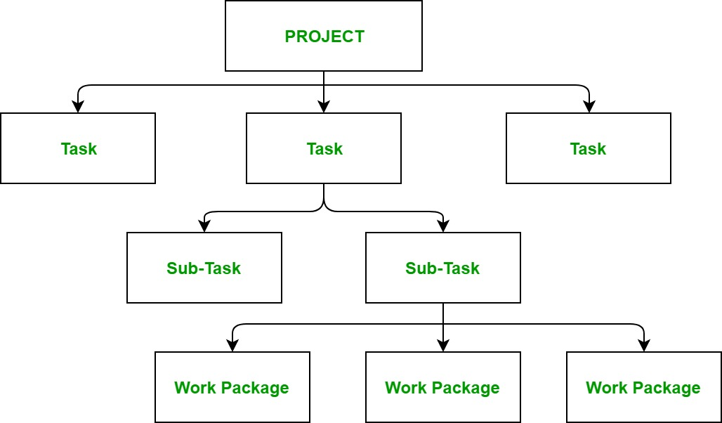

- Construction of Work Breakdown Structure:
Firstly, the project managers and top level management identifies the main deliverables of the project.
- After this important step, these main deliverables are broke down into smaller higher-level tasks and this complete process is done recursively to produce much smaller independent tasks.
- It depends on the project manager and team that upto which level of detail they want to break down their project.
Generally the lowest level tasks are the most simplest and independent tasks and takes less than two weeks worth of work. Hence, there is no rule for upto which level we may build the work breakdown structure of the project as it totally depends upon the type of project we are working on and the management of the company. The efficiency and success of the whole project majorly depends on the quality of the Work Breakdown Structure of the project and hence, it implies its importance.
Uses:
It allows to do a precise cost estimation of each activity.
It allows to estimate the time that each activity will take more precisely.
It allows easy management of the project.
It helps in proper organisation of the project by the top management.

Activity Network:
An activity network shows the different activities making up a project, their estimated durations, and their interdependencies.
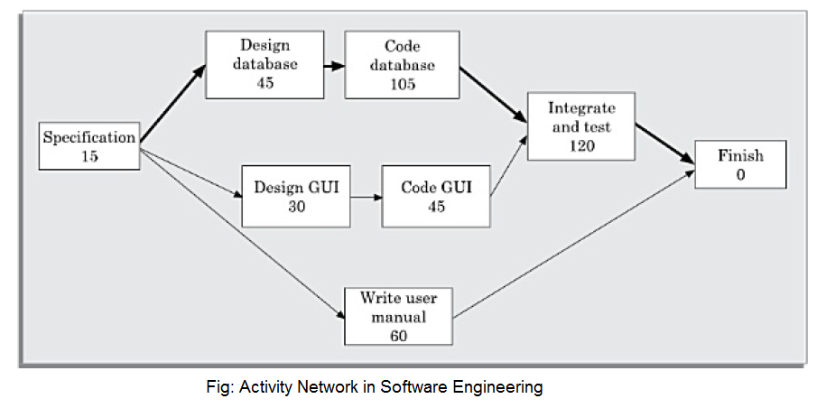

Activity on Node (AON):
In this representation, each activity is represented by a rectangular (some use circular) node and the duration of the activity is shown alongside each task in the node.

Activity on Edge (AOE):
In this representation tasks are associated with the edges. The edges are also annotated with the task duration. The nodes in the graph represent project milestones. Activity networks were originally represented using activity on edge (AOE) representation.

CPM AND PERT
Critical Path Method (CPM) is a method used in project planning, generally for project scheduling for the on-time completion of the project. It actually helps in the determination of the earliest time by which the whole project can be completed. There are two main concepts in this method namely critical task and critical path. Critical task is the task/activity which can’t be delayed otherwise the completion of the whole project will be delayed. It must be completed on-time before starting the other dependent tasks.
- Critical path is a sequence of critical tasks/activities and is the largest path in the project network.
- It gives us the minimum time which is required to complete the whole project.
- The activities in the critical path are known as critical activities and if these activities are delayed then the completion of the whole project is also delayed.
Major steps of the Critical Path Method:
- Identifying the activities
- Construct the project network
- Perform time estimation using forward and backward pass
- Identify the critical path
The table given below contains the activity label, its respective duration (in weeks) and its precedents. We will use critical path method to find the critical path and activities of this project.

Activity | Duration (in weeks) | Precedents
A | 6 | –
B | 4 | –
C | 3 | A
D | 4 | B
E | 3 | B
F | 10 | –
G | 3 | E, F
H | 2 | C, D

Rules for designing the Activity-on-Node network diagram:
- A project network should have only one start node
- A project network should have only one end node
- A node has a duration
- Links normally have no duration
- “Precedents” are the immediate preceding activities
- Time moves from left to right in the project network
- A network should not contain loops
- A network should not contain dangles
Node Representation:
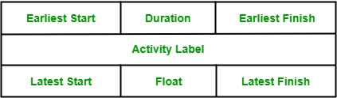

- Activity label is the name of the activity represented by that node.
- Earliest Start is the date or time at which the activity can be started at the earliest.
- Earliest Finish is the date or time at which the activity can completed at the earliest.
- Latest Start is the date or time at which the activity can be started at the latest.
- Latest Finish is the date or time at which the activity can be finished at the latest.
- Slack time (ST): The slack time (or float time) is the total time that a task may be delayed before it will affect the end time of the project. The slack time indicates the ”flexibility” in the starting and completion of tasks. ST for a task is LS-ES and can equivalently be written as LF-EF.

Activity-On-Node diagram:

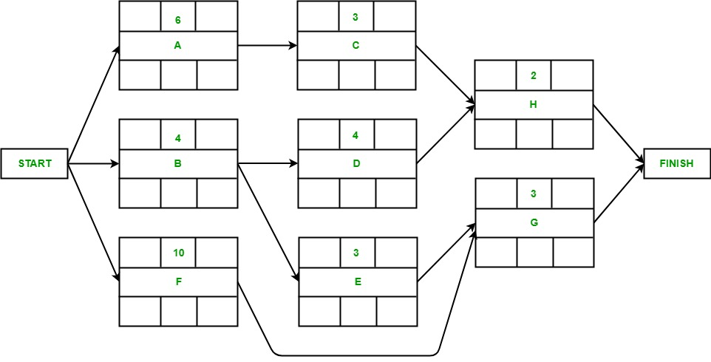
Forward Pass:
The forward pass is carried out to calculate the earliest dates on which each activity may be started and completed.
- Activity A may start immediately. Hence, earliest date for its start is zero i.e. ES(A) = 0. It takes 6 weeks to complete its execution. Hence, earliest it can finish is week 6 i.e. EF(A) = 6.
- Activity B may start immediately. Hence, earliest date for its start is zero i.e. ES(B) = 0. It takes 4 weeks to complete its execution. Hence, earliest it can finish is week 4 i.e. EF(B) = 4.
- Activity F may start immediately. Hence, earliest date for its start is zero i.e. ES(F) = 0. It takes 10 weeks to complete its execution. Hence, earliest it can finish is week 10 i.e. EF(F) = 10.
- Activity C starts as soon as activity A completes its execution. Hence, earliest week it can start its execution is week 6 i.e. ES(C) = 6. It takes 3 weeks to complete its execution. Hence, earliest it can finish is week 9 i.e. EF(C) = 9.
- Activity D starts as soon as activity B completes its execution. Hence, earliest week it can start its execution is week 4 i.e. ES(D) = 4. It takes 4 weeks to complete its execution. Hence, earliest it can finish is week 8 i.e. EF(D) = 8.
- Activity E starts as soon as activity B completes its execution. Hence, earliest week it can start its execution is week 4 i.e. ES(E) = 4. It takes 3 weeks to complete its execution. Hence, earliest it can finish is week 7 i.e. EF(E) = 7.
- Activity G starts as soon as activity E and activity F completes their execution. Since, activity requires the completion of both for starting its execution, we would consider the MAX(ES(E), ES(F)). Hence, earliest week it can start its execution is week 10 i.e. ES(G) = 10. It takes 3 weeks to complete its execution. Hence, earliest it can finish is week 13 i.e. EF(G) = 13.
- Activity H starts as soon as activity C and activity D completes their execution. Since, activity requires the completion of both for starting its execution, we would consider the MAX(ES(C), ES(D)). Hence, earliest week it can start its execution is week 9 i.e. ES(H) = 9. It takes 2 weeks to complete its execution. Hence, earliest it can finish is week 11 i.e. EF(H) = 11.

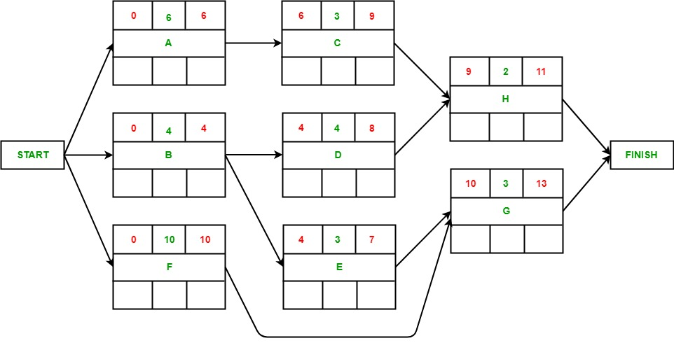
Backward Pass:
The backward pass is carried out to calculate the latest dates on which each activity may be started and finished without delaying the end date of the project.
Assumption: Latest finish date = Earliest Finish date (of project).
- Activity G’s latest finish date is equal to the earliest finish date of the precedent activity of finish according to the assumption i.e. LF(G) = 13. It takes 3 weeks to complete its execution. Hence, latest it can start is week 10 i.e. LS(G) = 10.
- Activity H’s latest finish date is equal to the earliest finish date of the precedent activity of finish according to the assumption i.e. LF(H) = 13. It takes 2 weeks to complete its execution. Hence, latest it can start is week 11 i.e. LS(H) = 11.
- The latest end date for activity C would be the latest start date of H i.e. LF(C) = 11. It takes 3 weeks to complete its execution. Hence, latest it can start is week 8 i.e. LS(C) = 8.
- The latest end date for activity D would be the latest start date of H i.e. LF(D) = 11. It takes 4 weeks to complete its execution. Hence, latest it can start is week 7 i.e. LS(D) = 7.
- The latest end date for activity E would be the latest start date of G i.e. LF(G) = 10. It takes 3 weeks to complete its execution. Hence, latest it can start is week 7 i.e. LS(E) = 7.
- The latest end date for activity F would be the latest start date of G i.e. LF(G) = 10. It takes 10 weeks to complete its execution. Hence, latest it can start is week 0 i.e. LS(F) = 0.
- The latest end date for activity A would be the latest start date of C i.e. LF(A) = 8. It takes 6 weeks to complete its execution. Hence, latest it can start is week 2 i.e. LS(A) = 2.
- The latest end date for activity B would be the earliest of the latest start date of D and E i.e. LF(B) = 7. It takes 4 weeks to complete its execution. Hence, latest it can start is week 3 i.e. LS(B) = 3.

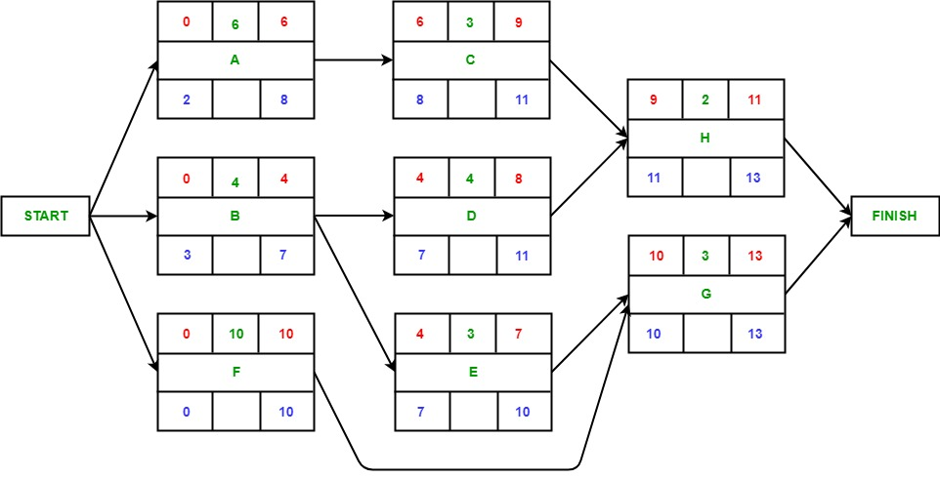
Identifying Critical Path:
Critical path is the path which gives us or helps us to estimate the earliest time in which the whole project can be completed. Any delay to an activity on this critical path will lead to a delay in the completion of the whole project. In order to identify the critical path, we need to calculate the activity float for each activity.
Activity float is actually the difference between an activity’s Earliest start and its latest start date or the difference between the activity’s Earliest finish and its latest finish date and it indicates that how much the activity can be delayed without delaying the completion of the whole project. If the float of an activity is zero, then the activity is an critical activity and must be added to the critical path of the project network. In this example, activity F and G have zero float and hence, are critical activities.
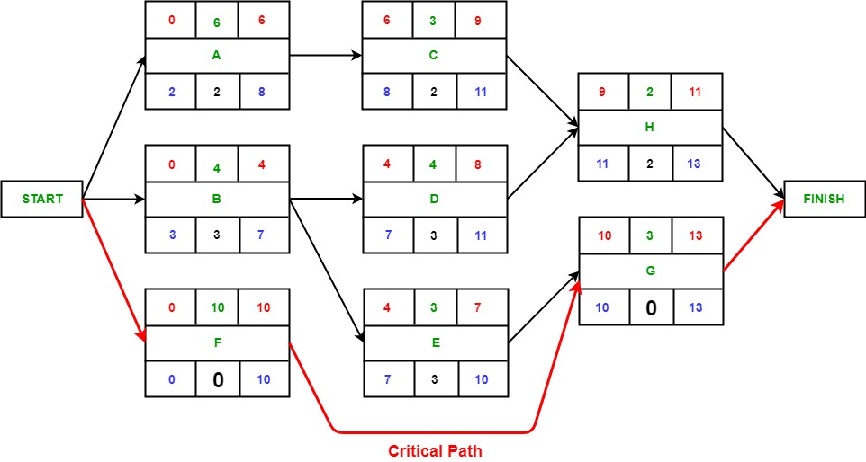

Project Evaluation and Review Technique (PERT)
Project Evaluation and Review Technique (PERT) is a procedure through which activities of a project are represented in its appropriate sequence and timing. It is a scheduling technique used to schedule, organize and integrate tasks within a project. PERT is basically a mechanism for management planning and control which provides blueprint for a particular project. All of the primary elements or events of a project have been finally identified by the PERT.
In this technique, a PERT Chart is made which represent a schedule for all the specified tasks in the project. The reporting levels of the tasks or events in the PERT Charts is somewhat same as defined in the work breakdown structure (WBS).
Characteristics of PERT:
The main characteristics of PERT are as following :
- It serves as a base for obtaining the important facts for implementing the decision-making.
- It forms the basis for all the planning activities.
- PERT helps management in deciding the best possible resource utilization method.
- PERT take advantage by using time network analysis technique.
- PERT presents the structure for reporting information.
- It helps the management in identifying the essential elements for the completion of the project within time.
Advantages of PERT:
It has the following advantages :
- Estimation of completion time of project is given by the PERT.
- It supports the identification of the activities with slack time.
- The start and dates of the activities of a specific project is determined.
- It helps project manager in identifying the critical path activities.
- PERT makes well organized diagram for the representation of large amount of data.
Disadvantages of PERT:
It has the following disadvantages :
- The complexity of PERT is more which leads to the problem in implementation.
- The estimation of activity time are subjective in PERT which is a major disadvantage.
- Maintenance of PERT is also expensive and complex.
- The actual distribution of may be different from the PERT beta distribution which causes wrong assumptions.
- It under estimates the expected project completion time as there is chances that other paths can become the critical path if their related activities are deferred.

Project Evaluation and Review Technique (PERT) is a procedure through which activities of a project are represented in its appropriate sequence and timing. It is a scheduling technique used to schedule, organize and integrate tasks within a project. PERT is basically a mechanism for management planning and control which provides blueprint for a particular project. All of the primary elements or events of a project have been finally identified by the PERT.
In this technique, a PERT Chart is made which represent a schedule for all the specified tasks in the project. The reporting levels of the tasks or events in the PERT Charts is somewhat same as defined in the work breakdown structure (WBS).
Characteristics of PERT:
The main characteristics of PERT are as following :
- It serves as a base for obtaining the important facts for implementing the decision-making.
- It forms the basis for all the planning activities.
- PERT helps management in deciding the best possible resource utilization method.
- PERT take advantage by using time network analysis technique.
- PERT presents the structure for reporting information.
- It helps the management in identifying the essential elements for the completion of the project within time.
Advantages of PERT:
It has the following advantages :
- Estimation of completion time of project is given by the PERT.
- It supports the identification of the activities with slack time.
- The start and dates of the activities of a specific project is determined.
- It helps project manager in identifying the critical path activities.
- PERT makes well organized diagram for the representation of large amount of data.
Disadvantages of PERT:
It has the following disadvantages :
- The complexity of PERT is more which leads to the problem in implementation.
- The estimation of activity time are subjective in PERT which is a major disadvantage.
- Maintenance of PERT is also expensive and complex.
- The actual distribution of may be different from the PERT beta distribution which causes wrong assumptions.
- It under estimates the expected project completion time as there is chances that other paths can become the critical path if their related activities are deferred.

At the core, PERT is all about management probabilities. Therefore, PERT involves in many simple statistical methods as well.
Sometimes, people categorize and put PERT and CPM together. Although CPM (Critical Path Method) shares some characteristics with PERT, PERT has a different focus.
Same as most of other estimation techniques, PERT also breaks down the tasks into detailed activities.
Then, a Gantt chart will be prepared illustrating the interdependencies among the activities. Then, a network of activities and their interdependencies are drawn in an illustrative manner.
In this map, a node represents each event. The activities are represented as arrows and they are drawn from one event to another, based on the sequence.
Next, the Earliest Time (TE) and the Latest Time (TL) are figured for each activity and identify the slack time for each activity.
When it comes to deriving the estimates, the PERT model takes a statistical route to do that. We will cover more on this in the next two sections.
Following is an example PERT chart:
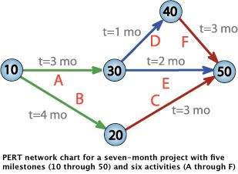

The Three Chances
There are three estimation times involved in PERT; Optimistic Time Estimate (TOPT), Most Likely Time Estimate (TLIKELY), and Pessimistic Time Estimate (TPESS).
In PERT, these three estimate times are derived for each activity. This way, a range of time is given for each activity with the most probable value, TLIKELY.’’

Following are further details on each estimate:

1. TOPT
This is the fastest time an activity can be completed. For this, the assumption is made that all the necessary resources are available and all predecessor activities are completed as planned.

2. TLIKELY
Most of the times, project managers are asked only to submit one estimate. In that case, this is the estimate that goes to the upper management.

3. TPESS
This is the maximum time required to complete an activity. In this case, it is assumed that many things go wrong related to the activity. A lot of rework and resource unavailability are assumed when this estimation is derived.

The PERT Mathematics
BETA probability distribution is what works behind PERT. The expected completion time (E) is calculated as below:
E = (TOPT + 4 x TLIEKLY + TPESS) / 6
At the same time, the possible variance (V) of the estimate is calculated as below:
V = (TPESS - TOPT)^2 / 6^2
Now, following is the process we follow with the two values:

For every activity in the critical path, E and V are calculated.
Then, the total of all Es are taken. This is the overall expected completion time for the project.
Now, the corresponding V is added to each activity of the critical path. This is the variance for the entire project. This is done only for the activities in the critical path as only the critical path activities can accelerate or delay the project duration.
Then, standard deviation of the project is calculated. This equals to the square root of the variance (V).
Now, the normal probability distribution is used for calculating the project completion time with the desired probability.

PERT chart

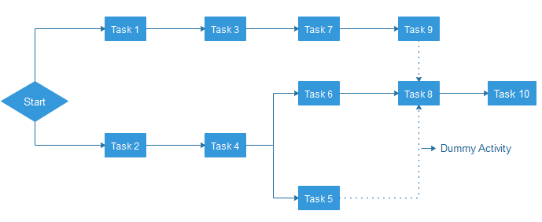
PERT is an acronym of Programme Evaluation Review Technique. In the 1950s, it is developed by the U.S. Navy to handle the Polaris submarine missile programme.
In Project Management, PERT chart represented as a network diagram concerning the number of nodes, which represents events.
The direction of the lines indicates the sequence of the task. In the above example, tasks between "Task 1 to Task 9" must complete, and these are known as a dependent or serial task. Between Task 4 and 5, and Task 4 and 6, nodes are not depended and can undertake simultaneously. These are known as Parallel or concurrent tasks. Without resource or completion time, the task must complete in the sequence which is considered as event dependency, and these are known as Dummy activity and represented by dotted lines.

What Is a Timeline Chart?
A timeline chart is a visual representation of a series of events. It can be created as a chart or a graph. Timeline charts can be created for anything that occurred over a period of time. You might see a timeline chart for World War II or major events of the 20th century. As a business owner, you might have a timeline chart of new product development or a sales campaign.
A timeline chart makes it easier to conceptualize a process or a sequence of events. It can make it easier for you to understand the intricacies of a project or why something seems to take so long to accomplish.

Timeline Chart Examples
There are three types of commonly used timeline charts. They include:
- Standard timeline chart
- Gantt chart
- Time series graph
The type of timeline chart that you create needs to correspond with the information it covers and the purpose for making it. Here are some common uses of a simple timeline chart:
- Helps to manage and keep complex tasks on time.
- Allows you to visualize a process or events that took place over a period of time.
- Works as an aid to decision-making about current and future projects.
- Allocation of resources at the right time because easier.
A timeline chart offers a variety of uses. A standard timeline chart is easy to create for almost any event or process.

Gantt chart
- Gantt Chart first developed by Henry Gantt in 1917.
- Gantt chart usually utilized in project management, and it is one of the most popular and helpful ways of showing activities displayed against time.
- Each activity represented by a bar.
Gantt chart is a useful tool when you want to see the entire landscape of either one or multiple projects. It helps you to view which tasks are dependent on one another and which event is coming up.
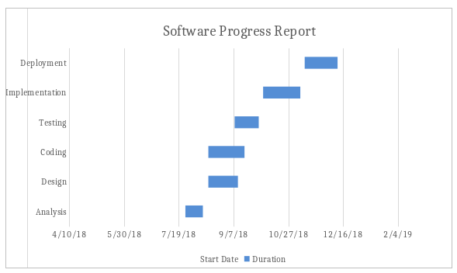
Earned Value Analysis (EVA) is one of the key tools and techniques used in Project Management, to have an understanding of how the project is progressing. EVA implies gauging the progress based on earnings or money. Both, schedule and cost are calculated on the basis of EVA.

Features of EVA
- Earned Value Analysis is an objective method to measure project performance in terms of scope, time and cost.
- EVA metrics are used to measure project health and project performance.
- Earned Value Analysis is a quantitative technique for assessing progress as the software project team moves through the work tasks, allocated to the Project Schedule.
- EVA provides a common value scale for every project task.
- Total hours to complete the project are estimated and every task is given an Earned Value, based on its estimated (%) of the total.
- Earned Value is a measure of ‘Progress’ to assess ‘Percentage of Completeness’
Project Manager evaluates project’s triple constraint of scope, time and cost.
Key Questions
Is the project performing to budget?
Is the project on schedule to deliver the agreed scope?
Typically Summarize Project Health using Green, Yellow, Red Status (Traffic Light Reporting)

EVA Example:

Suppose your team lands a project of constructing pillars on a large area of land.
The plan is laid down as below-
30 batches of 20 pillars that makes 600 pillars
5 batches per day, i.e. 100 pillars
The cost budgeted per pillar $2.90
The total budget is $1740
On your team’s first day, 70 pillars were constructed due to a stone covered patch that needed to be removed before constructing pillars. The cost incurred in renting a stone removal machine was $147 for a day.
The earned value calculation would be as such-
Earned Value | = 70 pillars constructed x $2.90 | = $203
Budgeted Cost | = 100 pillars constructed per day x $2.90 | = $290
Actual Cost | = 70 pillars constructed x $2.90 + $147 for the machine | = $350
The above-mentioned earned value calculation example is visualized by Plainsware, a software toolkit to practice earned value management as below-
By visualising the actual, budgeted, and earned costs, we can calculate the cost variances that are essential to evaluate profitability. The project is witnessing 58% more spend on costs (203/350) over the budget. This is called the cost performance index.

WHAT ARE THE REQUIREMENTS AND INDEXES OF EARNED VALUE ANALYSIS?
The foremost prerequisite to earning value analysis is a well-defined project plan as exemplified in the above-mentioned scenario. A plan can be drafted as a step-by-step breakdown of all the tasks to be accomplished within the project.
The entire cycle of collecting prerequisites, monitoring resource performance, and evaluating cost, time, and schedule variances are known as ‘Earned Value Management” or EVM.
Below is a list of all the elements that factor in EVM calculation for successful project management-
- Work Breakdown Structure (WBS)
WBS is a hierarchical distribution of the total work to be performed by a team to achieve a project’s final objective. It is usually presented in the form of a document or spreadsheet. WBS lists down all the deliverables along with the respective budget, time, cost, and schedule to be followed.
- Planned Value
Once WBS sets the foundation of EVM analysis, we need to estimate the planned value or the Budgeted Cost of Work Scheduled (BCWS). Simply put, planned value is the percentage of tasks that should be completed at a given time.
Referring to the above example,
PV = $290 (100 pillars constructed per day x $2.90 budget per pillar)
- Earned Value
Earned value or EV is the number of tasks that stands complete at a given time. EV, also known as Budgeted Cost of Work Performed (BCWP), can be expressed in percentage or monetary terms.
The basic earned value analysis formula is as such-
EV = Work actually complete x Task Budget
- Actual Cost
The actual cost is the sum of all the efforts that are invested in a project at a given time. It encompasses several factors like labour hours, material, equipment, fixed cost items, and more.
Remember, the actual cost can be expressed both in terms of work hours or monetary terms. However, to maintain a standard for EVM analysis, it is advisable to derive all the requirements in a common monetary unit.
- Scheduled Variance
Scheduled variance (SV) reflects the scheduled status in terms of the cost of the project.
SV = EV – PV
Citing the pillar example,
SV = $203 – $290
= -$87
Apparently, a negative schedule variance denotes that the team is lacking behind the schedule and vice versa.
- Cost Variance
The cost variance provides the cost status of the project at the given time. It can be expressed in monetary and percentage formats.
CV = EV – AC
Again, the above example can be used to calculate CV-
CV = $203 – $350
= -$147
The project was well over the budget by as much as 58% [(203/350) x100]. Had the CV been positive, the team would have made a considerable profit at the project completion.
- Other Performance Indicators
There are some other indicators and parameters of project status that are equally significant to earn value analysis. These are-
Schedule Performance Index = EV / PV
Cost Performance Index = EV / AC
Estimate at Completion = AC + BAC -EV
Estimate to Complete = EAC – AC
To Complete Performance Index = (BAC – EV) / (BAC – AC)
All these metrics and parameters are essential components of earned value analysis. In the last section, we shall learn more about earned value analysis in software project management by exploring some important earned value types.

3. WHAT IS EARNED VALUE TYPES?
Earned value types are numerous ways in which a project’s performance will be claimed or drawn upon the baseline. Here’s are various earned value types that can be employed in earned value analysis in software engineering or other project niches-
- 50/50 and XX/YY
Claiming the first 50% of the performance as soon as the project is started and the remaining 50% on completion.
- 0-100
Claiming nothing before the completion and delivery of the project at which 100% is claimed. 0-100 EVT is usually preferred for projects that involve tasks rendered in one period.
- Incremental Milestones
Setting budgetary milestones throughout the project’s trajectory and claiming performance after achieving every milestone, say 25%.
- Units Complete
Calculating the percentage of work complete based upon the units complete. For instance, 70% of a day’s job was complete after constructing 70 pillars out of the 100 planned.
- Percentage Complete
Evaluating performance or work complete based on experience without any solid evidence or metrics supporting the calculation.
- Apportioned Effort
Supporting activities performed by other direct activities such as QA testing in software development and assurance.
- Level of Effort
Claiming performance following a uniform set of work performance rates over a period of time throughout the project completion. Often referred to as LoE, it can be measured by keeping the baseline values parallel, i.e. EV = PV.
Software Re-engineering

Software Re-engineering is a process of software development which is done to improve the maintainability of a software system. Re-engineering is the examination and alteration of a system to reconstitute it in a new form. This process encompasses a combination of sub-processes like reverse engineering, forward engineering, reconstructing etc.
Re-engineering is the reorganizing and modifying existing software systems to make them more maintainable.

Objectives of Re-engineering:
- To describe a cost-effective option for system evolution.
- To describe the activities involved in the software maintenance process.
- To distinguish between software and data re-engineering and to explain the problems of data re-engineering.

Steps involved in Re-engineering:
- Inventory Analysis
- Document Reconstruction
- Reverse Engineering
- Code Reconstruction
- Data Reconstruction
- Forward Engineering

Diagrammatic Representation:

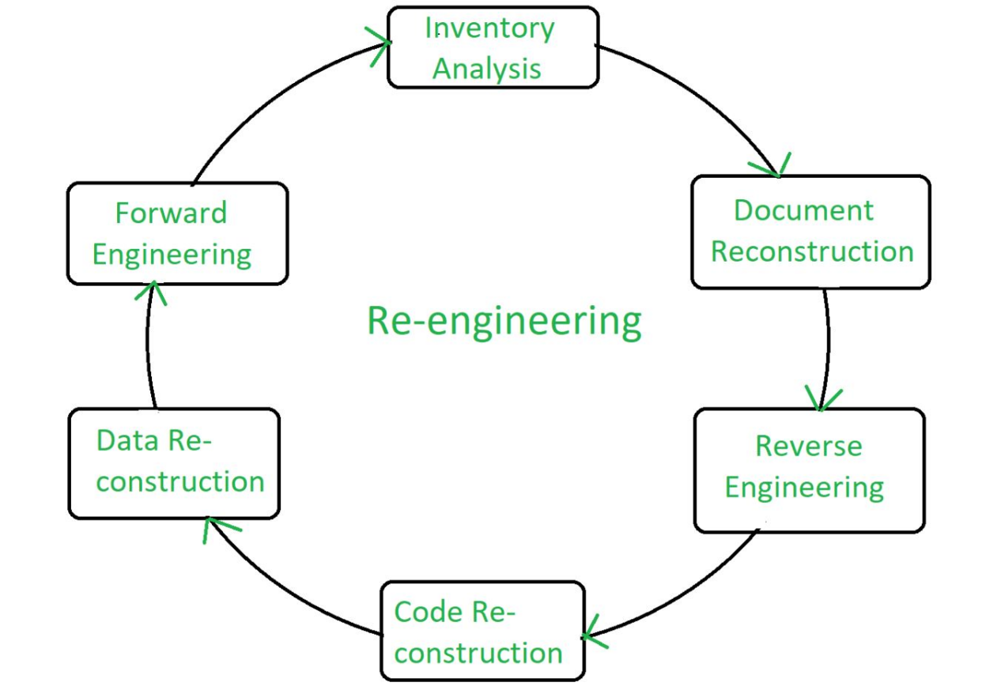

Re-engineering Cost Factors:
- The quality of the software to be re-engineered
- The tool support available for re-engineering
- The extent of the required data conversion
- The availability of expert staff for re-engineering
Advantages of Re-engineering:

- Reduced Risk: As the software is already existing, the risk is less as compared to new software development. Development problems, staffing problems and specification problems are the lots of problems which may arise in new software development.
- Reduced Cost: The cost of re-engineering is less than the costs of developing new software.
- Revelation of Business Rules: As a system is re-engineered , business rules that are embedded in the system are rediscovered.
- Better use of Existing Staff: Existing staff expertise can be maintained and extended accommodate new skills during re-engineering.
Disadvantages of Re-engineering:
- Practical limits to the extent of re-engineering.
- Major architectural changes or radical reorganizing of the systems data management has to be done manually.
- Re-engineered system is not likely to be as maintainable as a new system developed using modern software Re-engineering methods.

Reverse Engineering
Software Reverse Engineering is a process of recovering the design, requirement specifications and functions of a product from an analysis of its code. It builds a program database and generates information from this.
The purpose of reverse engineering is to facilitate the maintenance work by improving the understandability of a system and to produce the necessary documents for a legacy system.
Reverse Engineering Goals:
- Code with Complexity.
- Recover lost information.
- Detect side effects.
- Synthesise higher abstraction.
- Facilitate Reuse.
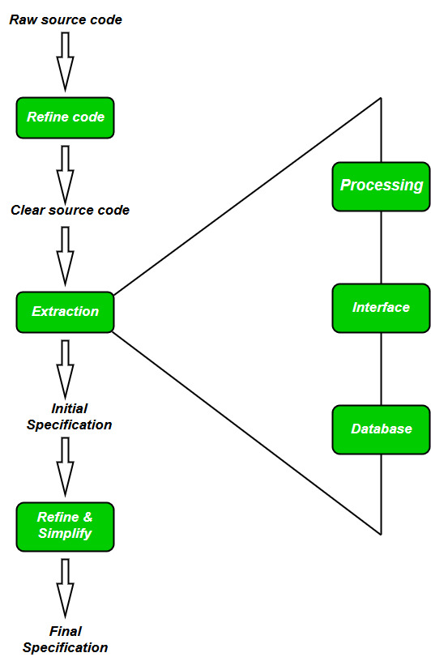
Steps of Software Reverse Engineering:

- Collection Information:
This step focuses on collecting all possible information (i.e., source design documents etc.) about the software.
- Examining the information:
The information collected in step-1 as studied so as to get familiar with the system.
- Extracting the structure:
This step concerns with identification of program structure in the form of structure chart where each node corresponds to some routine.
- Recording the functionality:
During this step processing details of each module of the structure, charts are recorded using structured language like decision table, etc.
- Recording data flow:
From the information extracted in step-3 and step-4, set of data flow diagrams are derived to show the flow of data among the processes.
- Recording control flow:
High level control structure of the software is recorded.
- Review extracted design:
Design document extracted is reviewed several times to ensure consistency and correctness. It also ensures that the design represents the program.
- Generate documentation:
Finally, in this step, the complete documentation including SRS, design document, history, overview, etc. are recorded for future use.

BUSINESS PROCESS REENGINEERING
“Business Process Re-engineering is the fundamental rethinking and radical design of business processes to achieve dramatic improvements in critical, contemporary measures of performance such as cost, quality, service and speed.”
Business process re-engineering is not just a change, but actually it is a dramatic change and dramatic improvements. This is only achieved through overhaul the organization structures, job descriptions, performance management, training and the most importantly, the use of IT i.e. Information Technology.
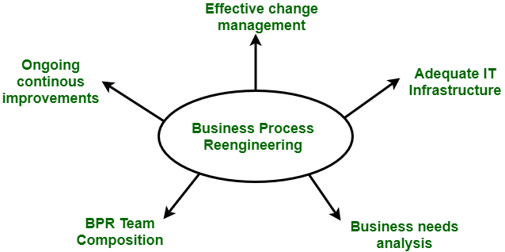
BPR projects have failed sometimes to meet high expectations. Many unsuccessful BPR attempts are due to the confusion surrounding BPR and how it should be performed. It becomes the process of trial and error.
Phases of BPR :
According to Peter F. Drucker, ” Re-engineering is new, and it has to be done.” There are 7 different phases for BPR. All the projects for BPR begin with the most critical requirement i.e. communication throughout the organization.
- Begin organizational change.
- Build the re-engineering organization.
- Identify BPR opportunities.
- Understand the existing process.
- Reengineer the process
- Blueprint the new business system.
- Perform the transformation.
Objectives of BPR :
Following are the objectives of the BPR :
- To dramatically reduce cost.
- To reduce time requirements.
- To improve customer services dramatically.
- To reinvent the basic rules of the business e.g. The airline industry.
- Customer satisfaction.
- Organizational learning.
Challenges faced by BPR process :
All the BPR processes are not as successful as described. The companies that have start the use of BPR projects face many of the following challenges :
- Resistance
- Tradition
- Time requirements
- Cost
- Job losses
Advantages of BPR :
Following are the advantages of BPR :
- BPR offers tight integration among different modules.

